ECEN 325

Lab 11: MOSFET Amplifier Configurations

Section 506

04/24/2020

Jason Gilman

TA: Mandela

**Calculations**

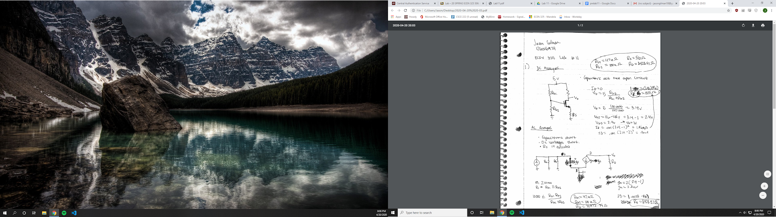

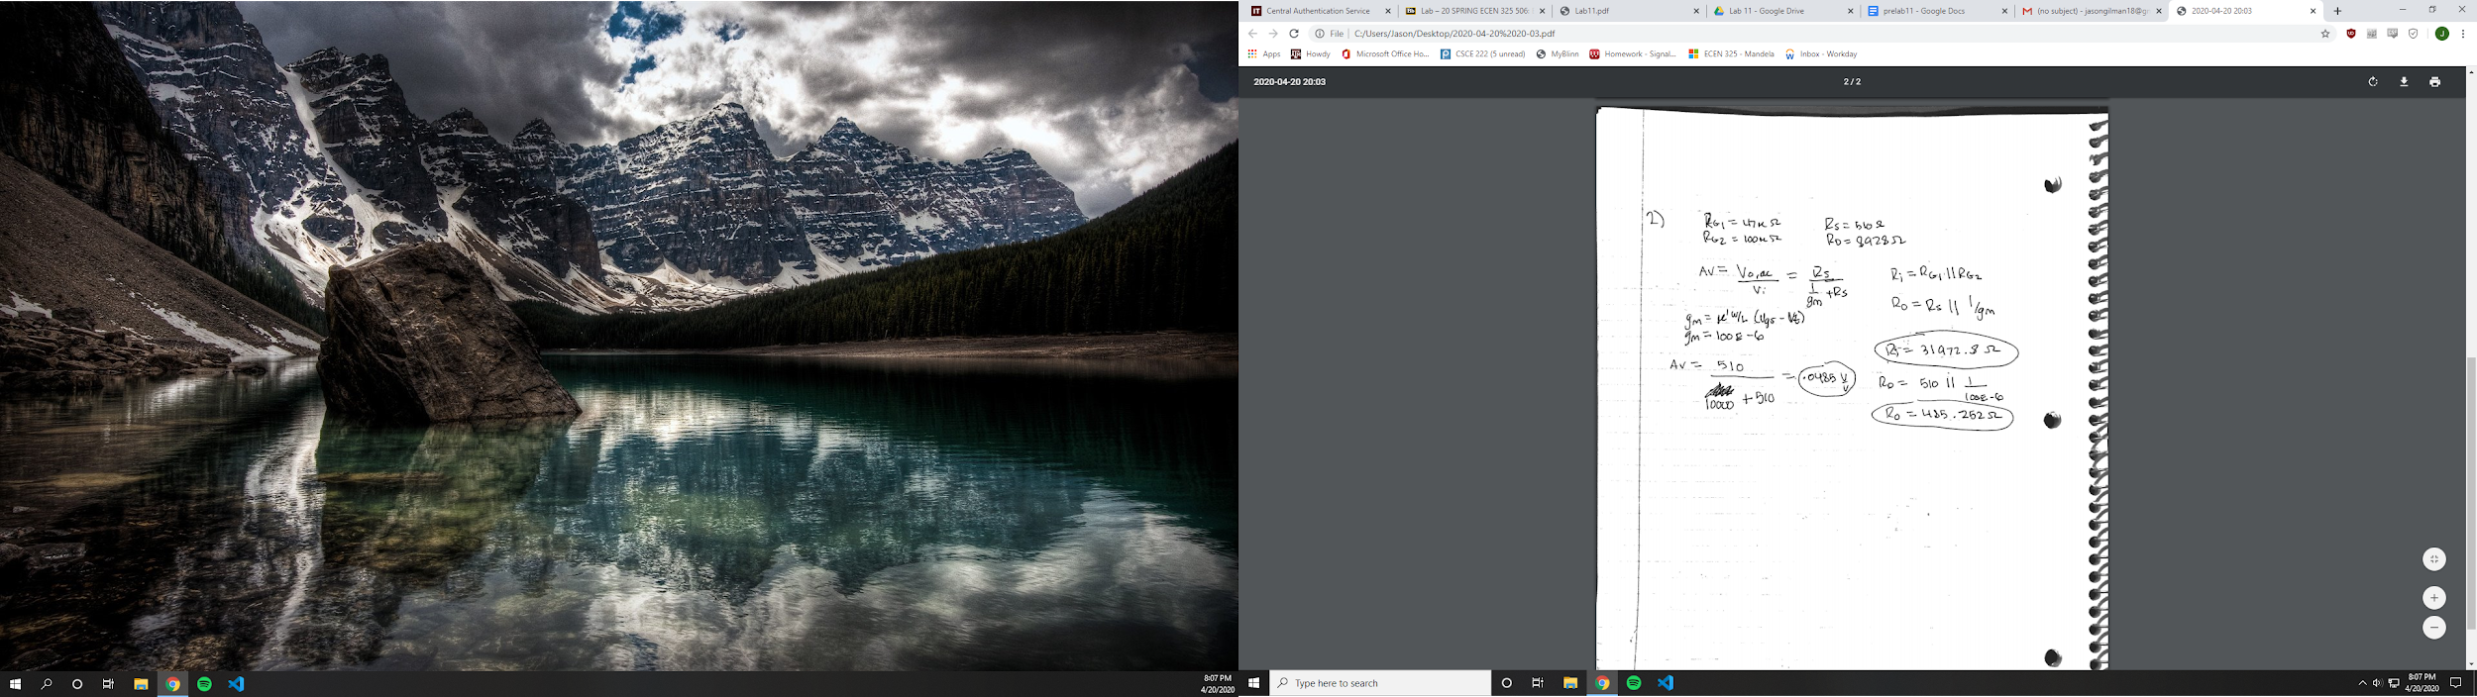

**Simulations**

Common source

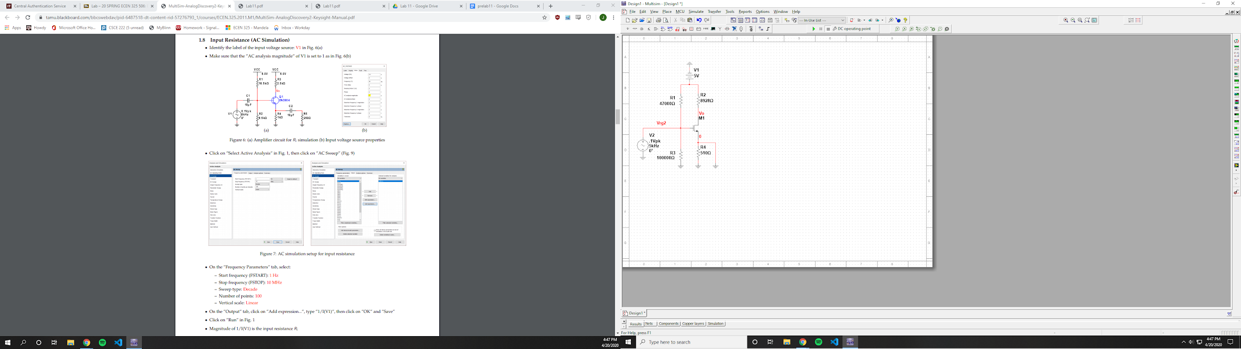

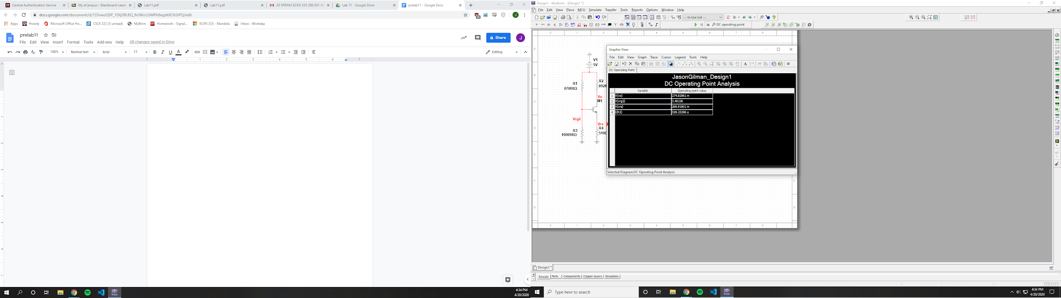

Vrg2 = 3.40136 V

Vrs = 269.91901 mV

Id = 529.25296 uA

Vd = 274.82961 mV

Vo = 274.82961 mV

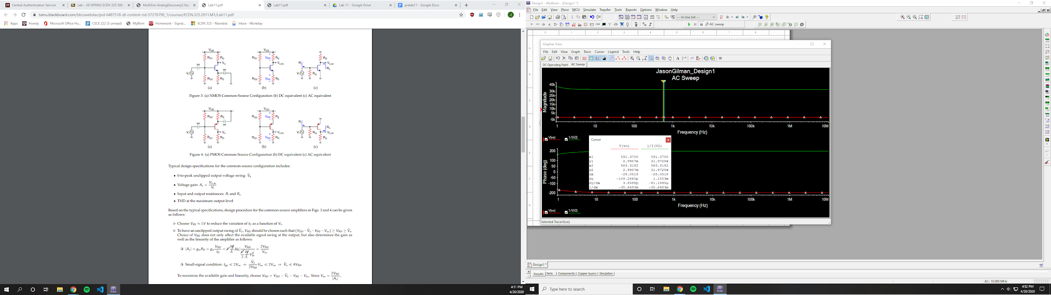

Ri = 31.9728 k Ohms

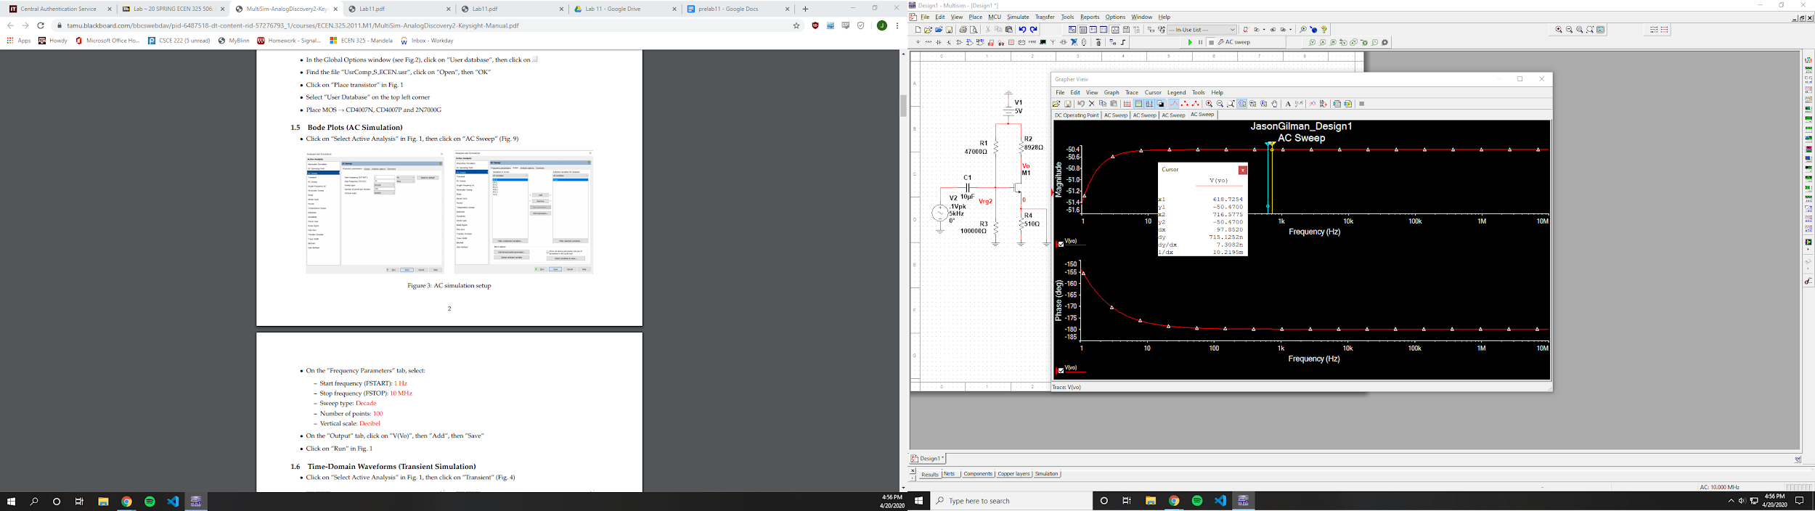

Av = -50.47 dB

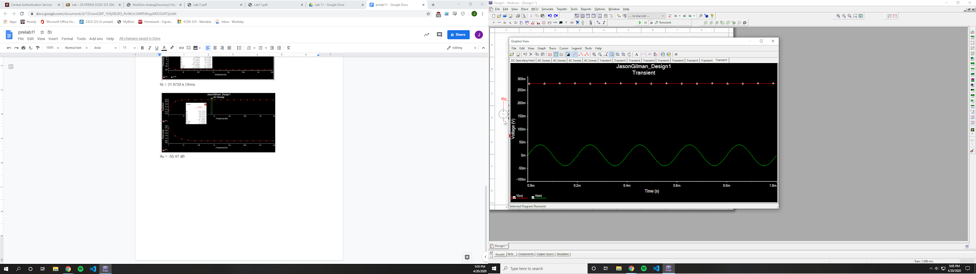

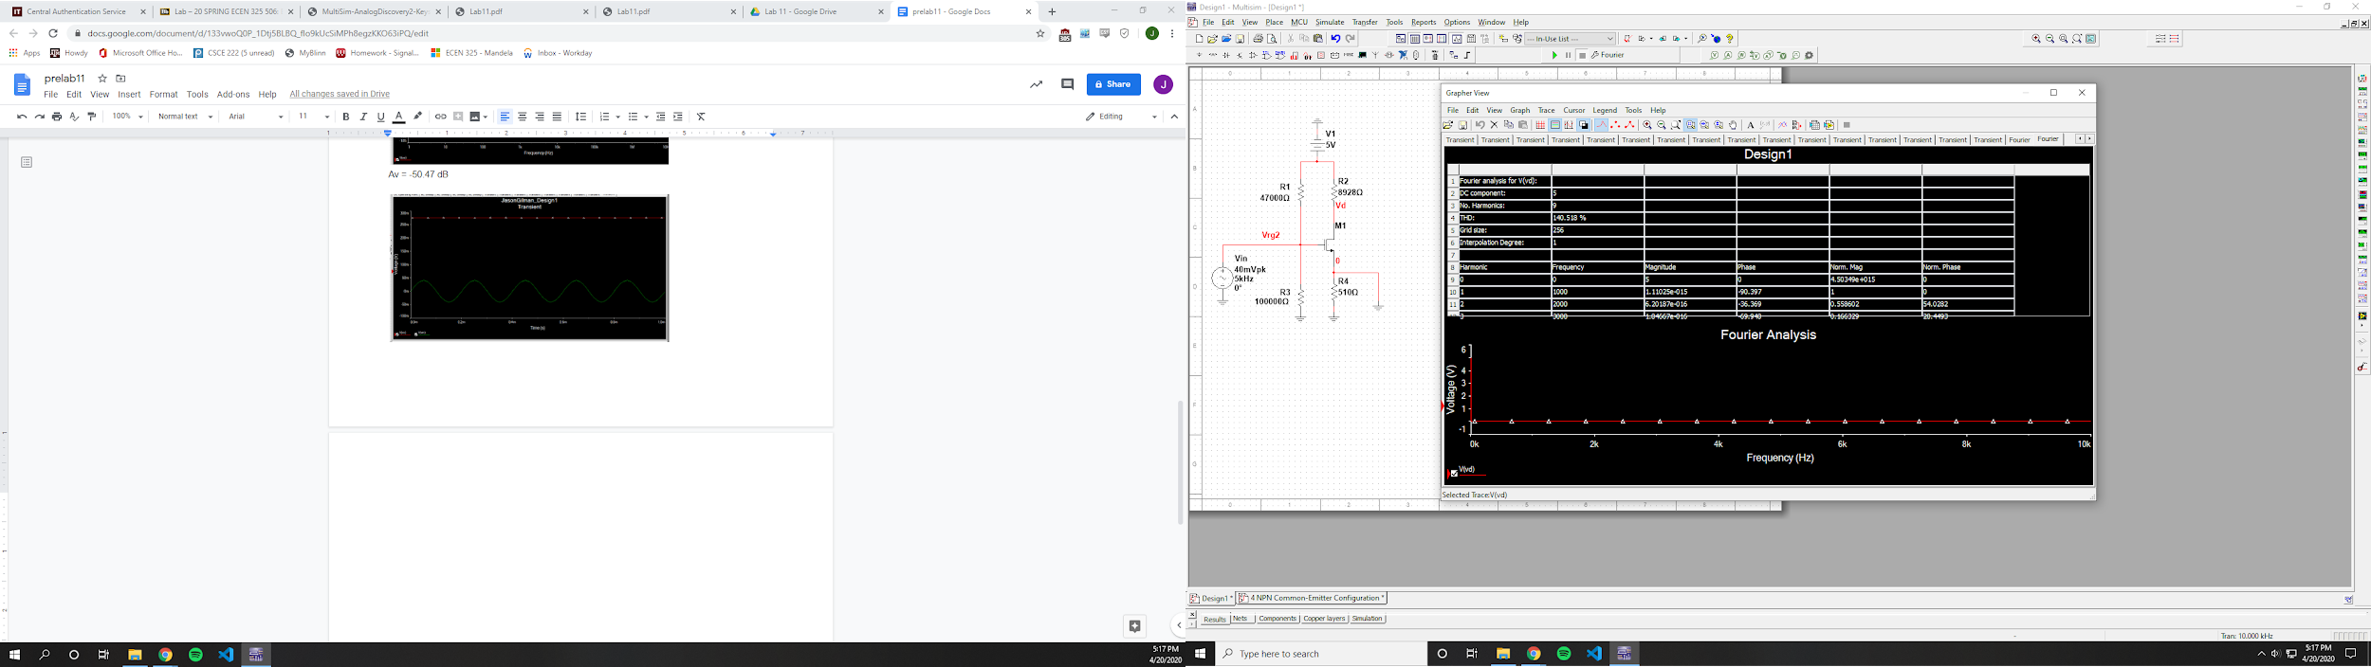

THD = 140.518%

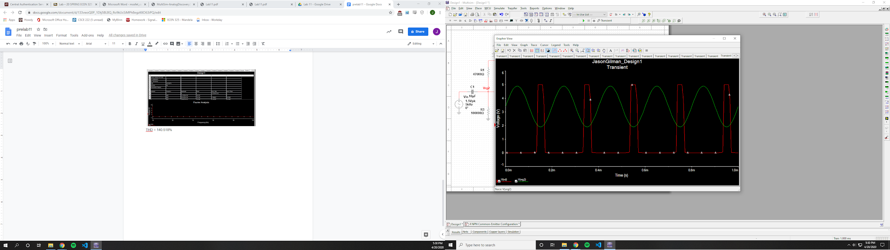

V_clipping = 1.5 V

Source Follower

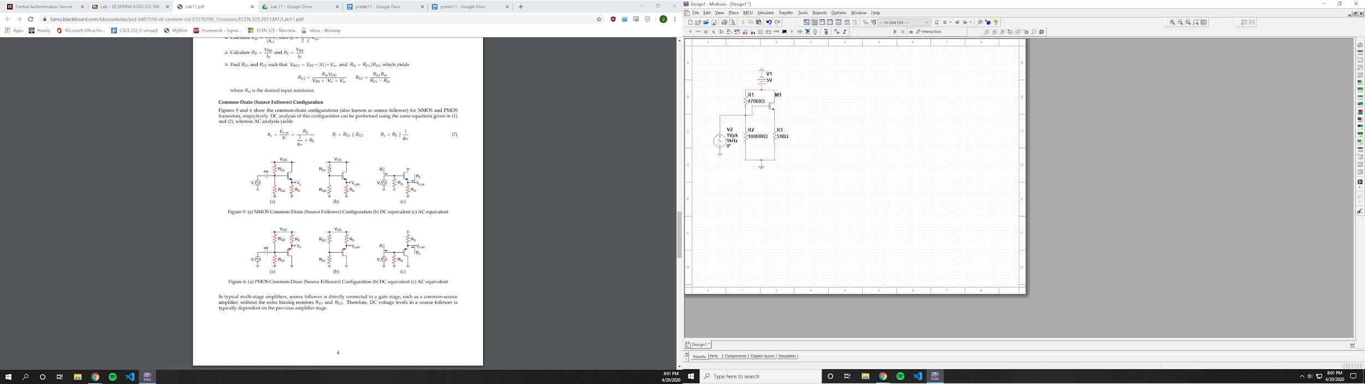

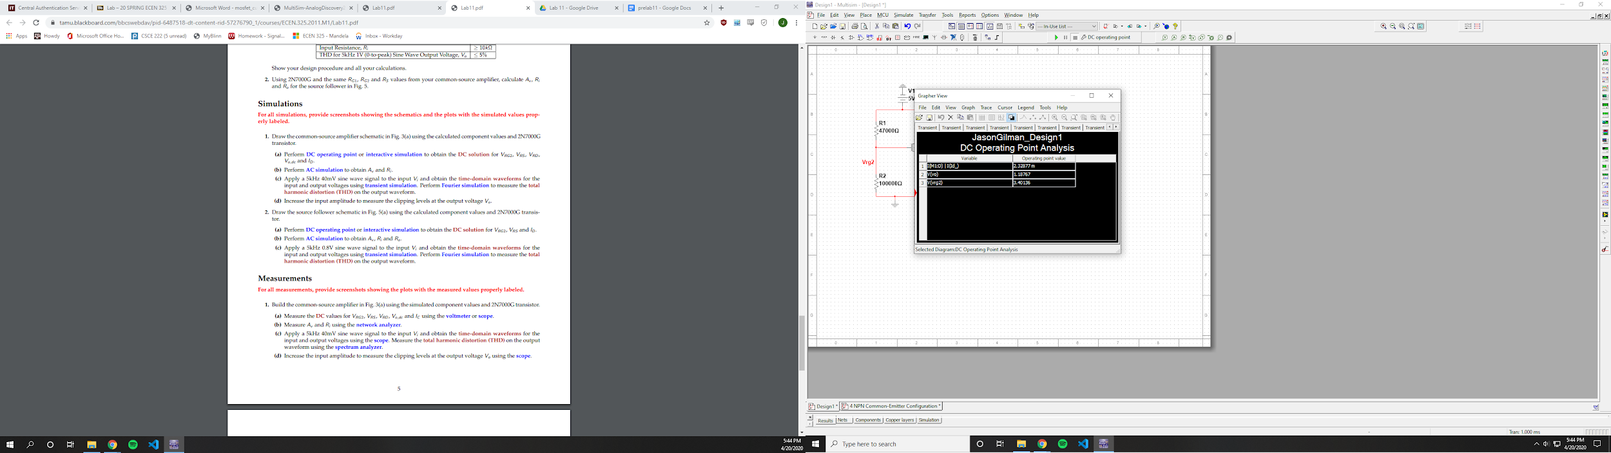

Id = 2.32877 mA

Vs = 1.18767 V

Vrg2 = 4.40136 V

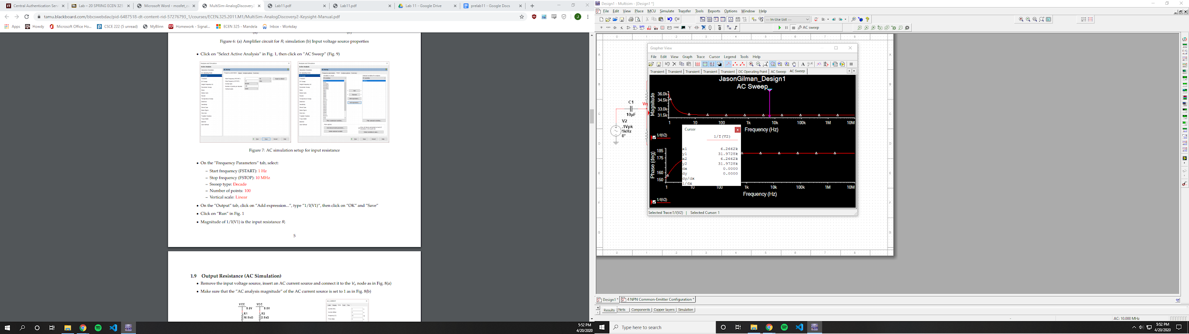

Ri = 31.9728 kOhms

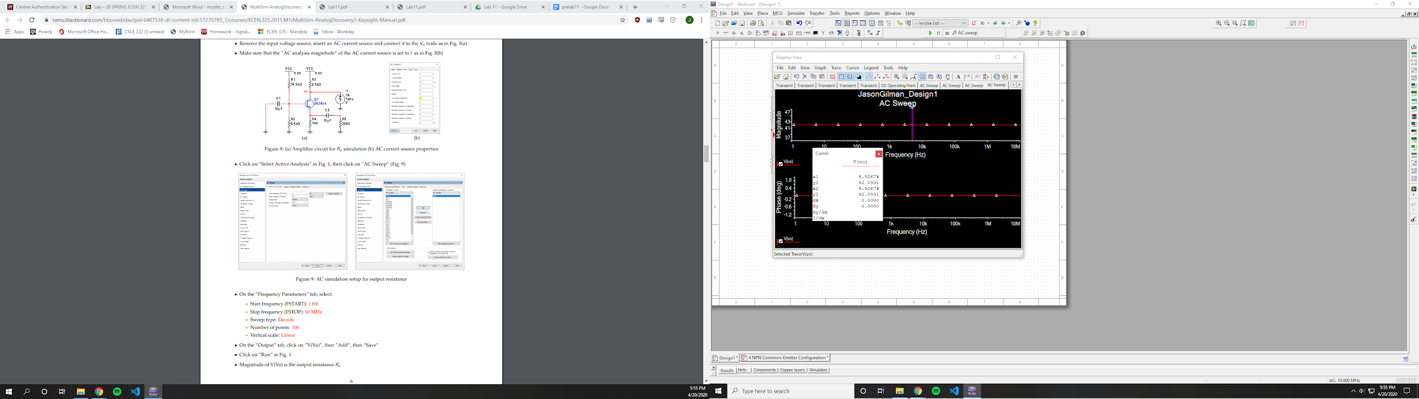

Ro = 42.0931 Ohms

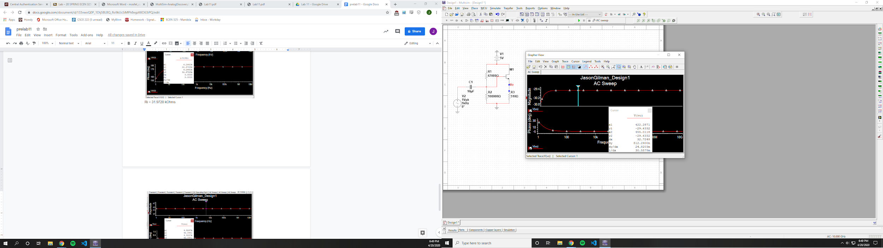

Av = -29.6332

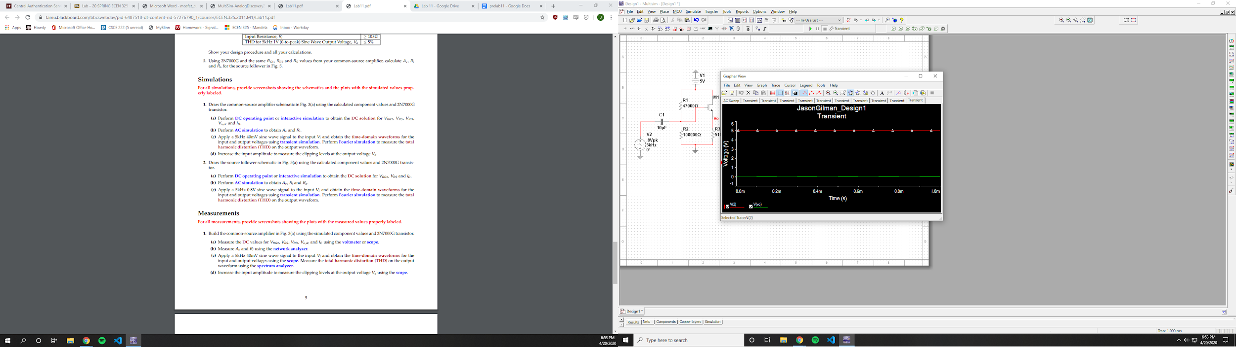

Had trouble getting the vo to show correctly

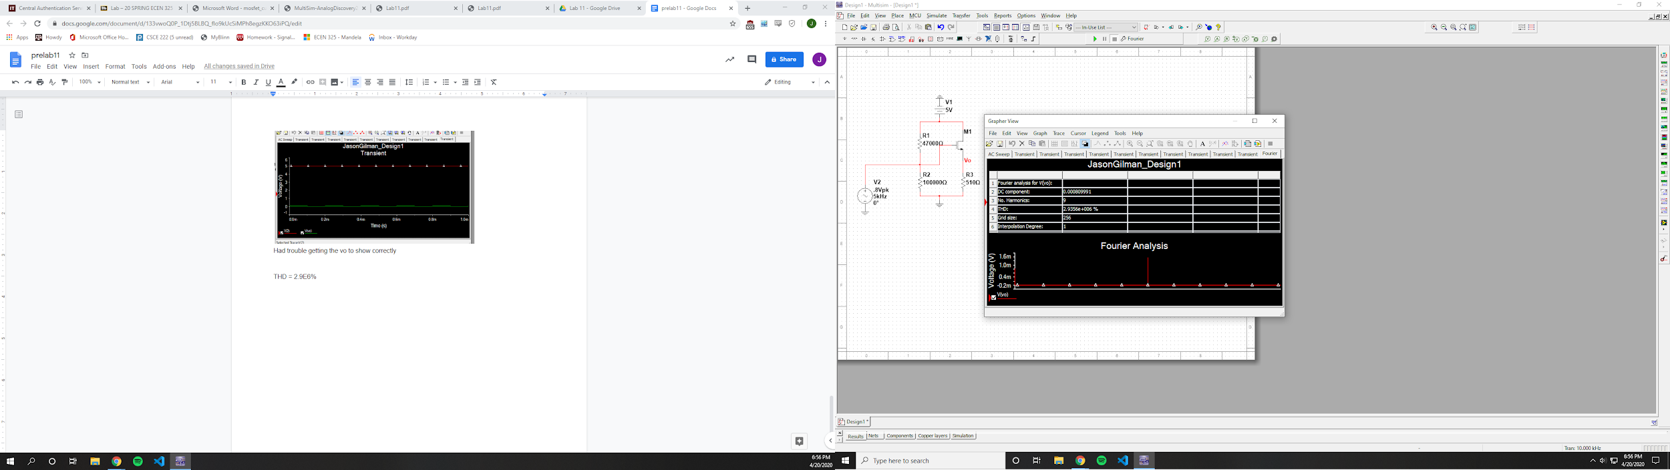

THD = 2.9E6%

**Measurements**

Common Source

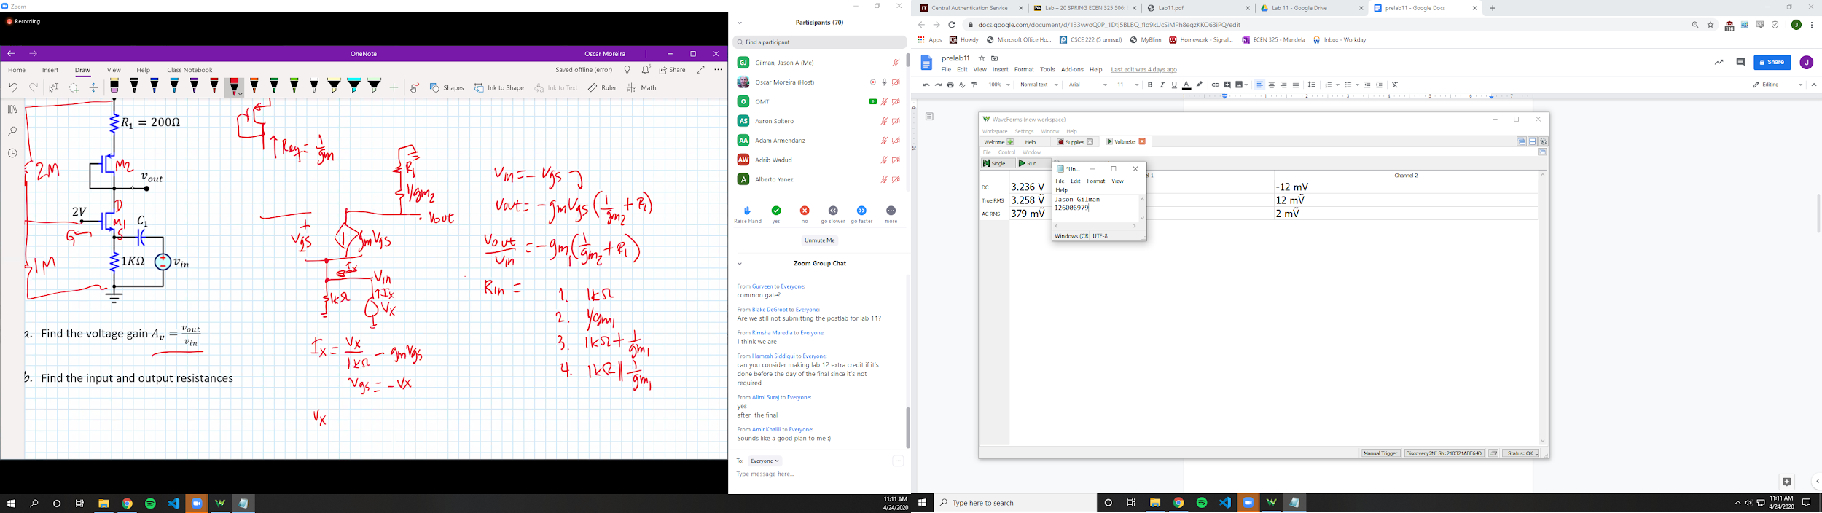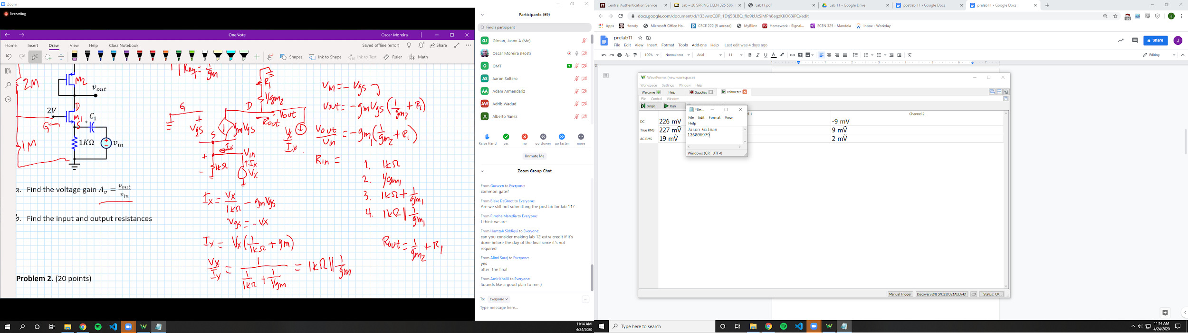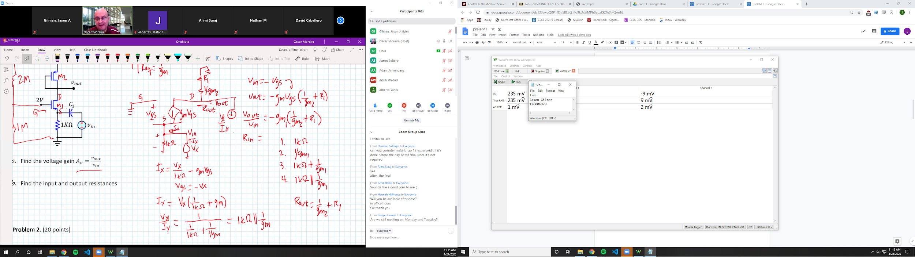

Vrg2 = 3.236 V

Vrs = .226 V

Vrd = .235 V

Vo = .235 V

Id = .049687 mA

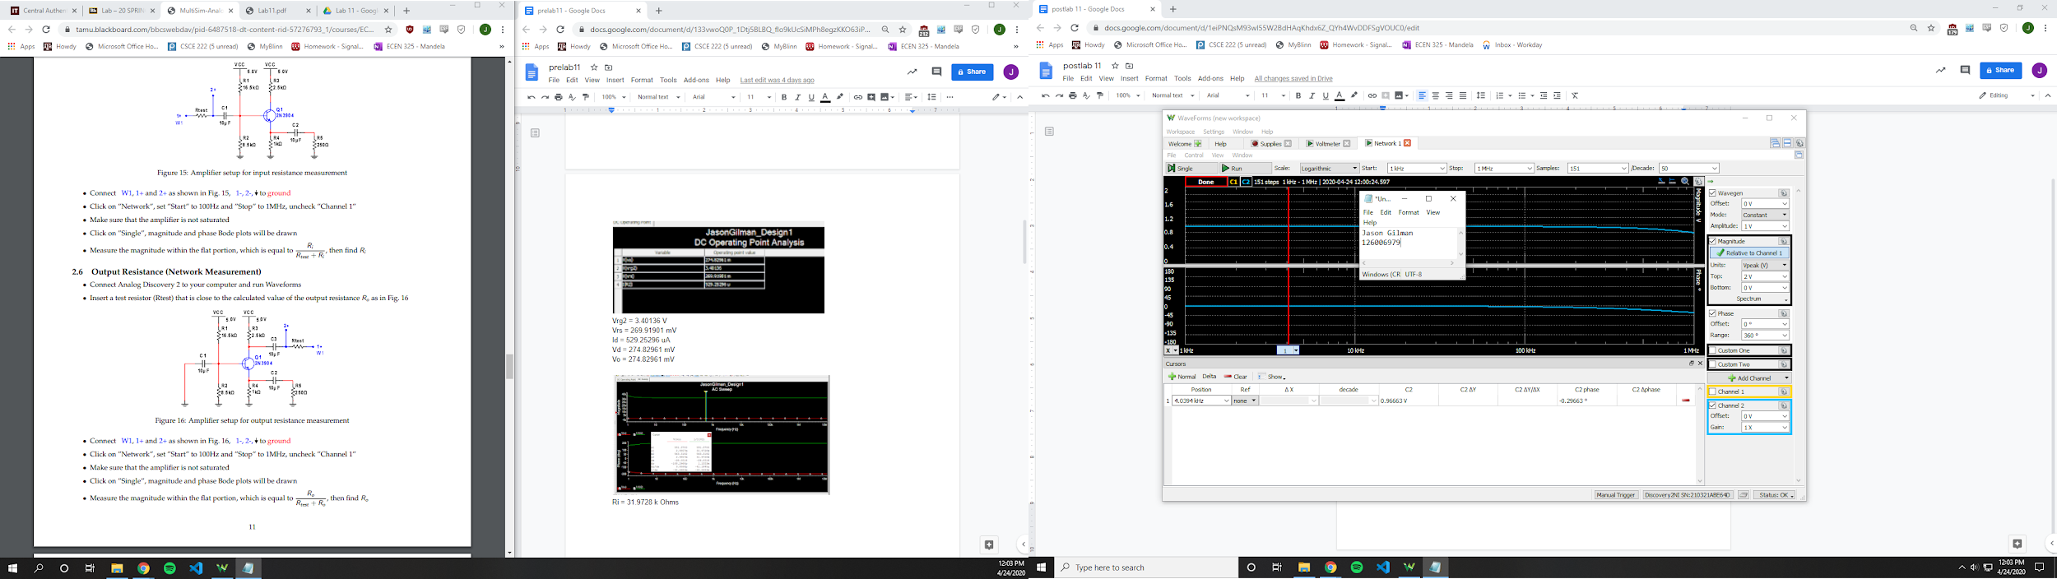

Ri = 28967 Ohms

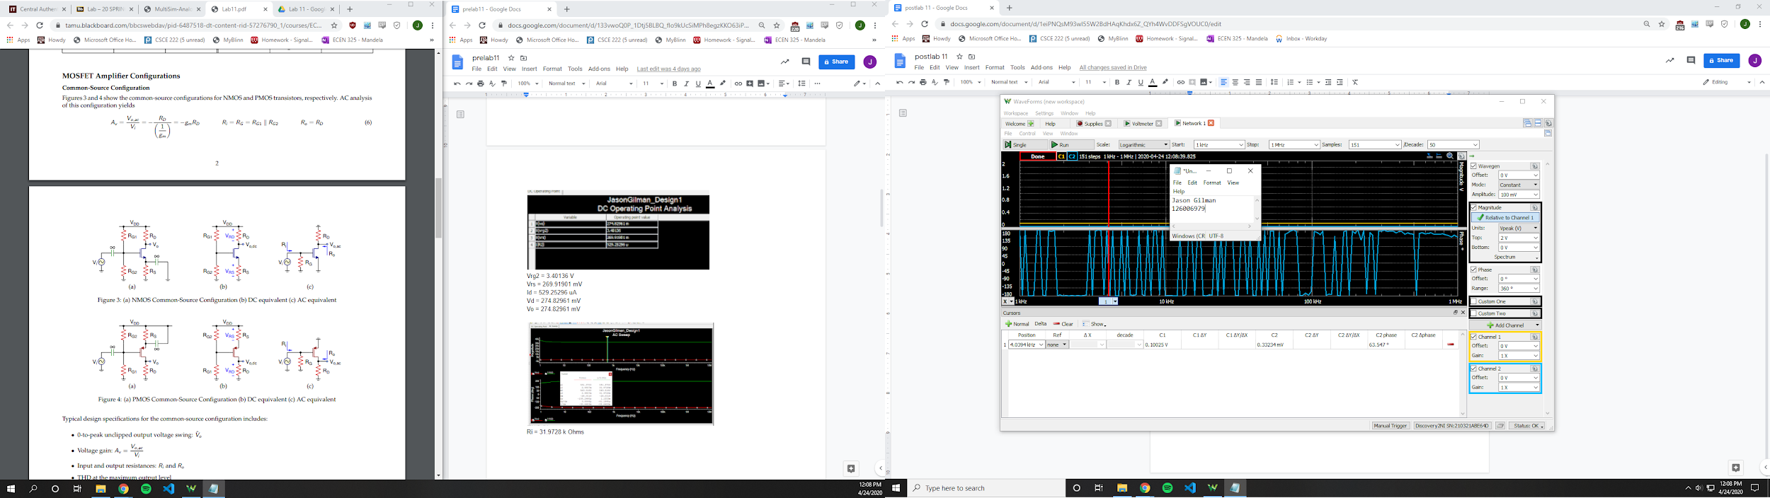

Av = 3.35

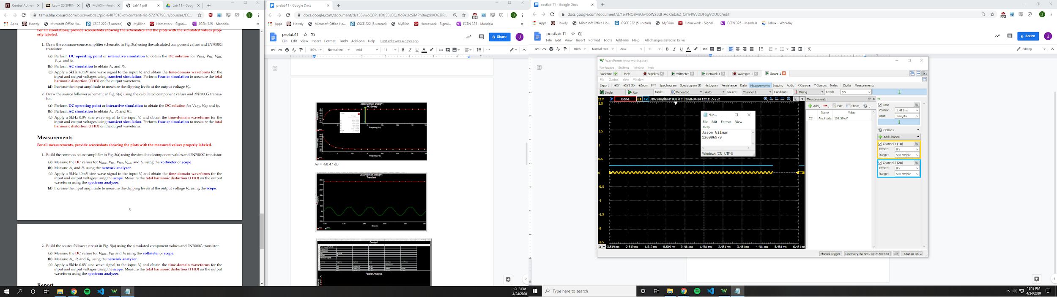

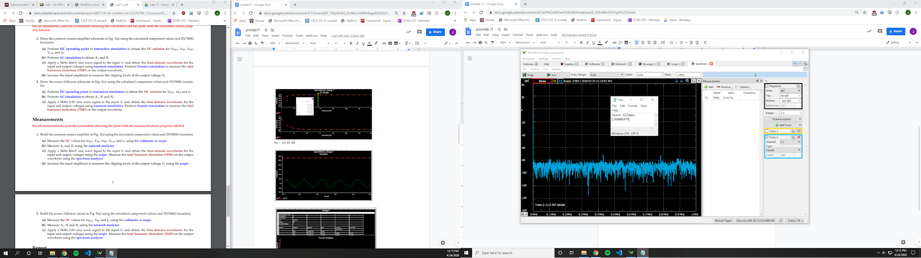

THD = 14.62 %

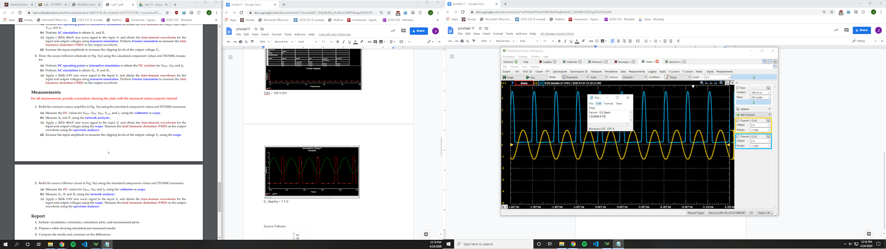

V_clipping = 1.2 V

Source Follower

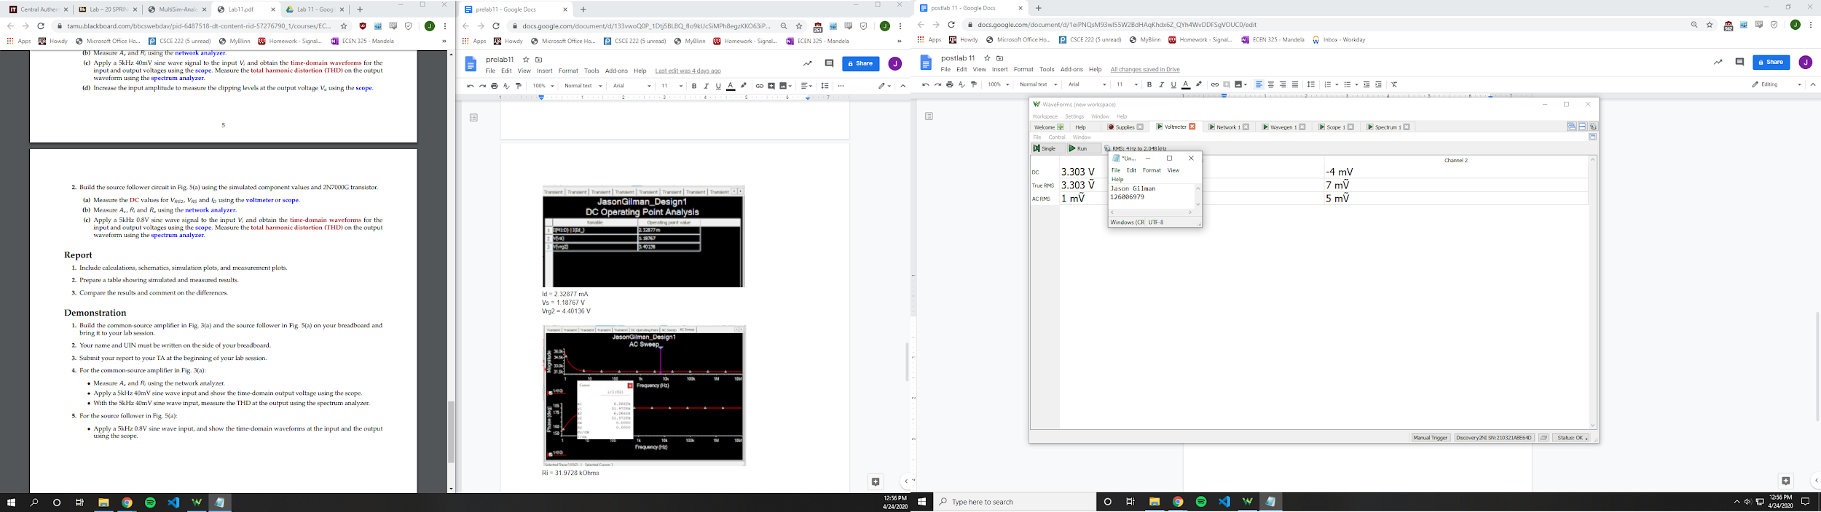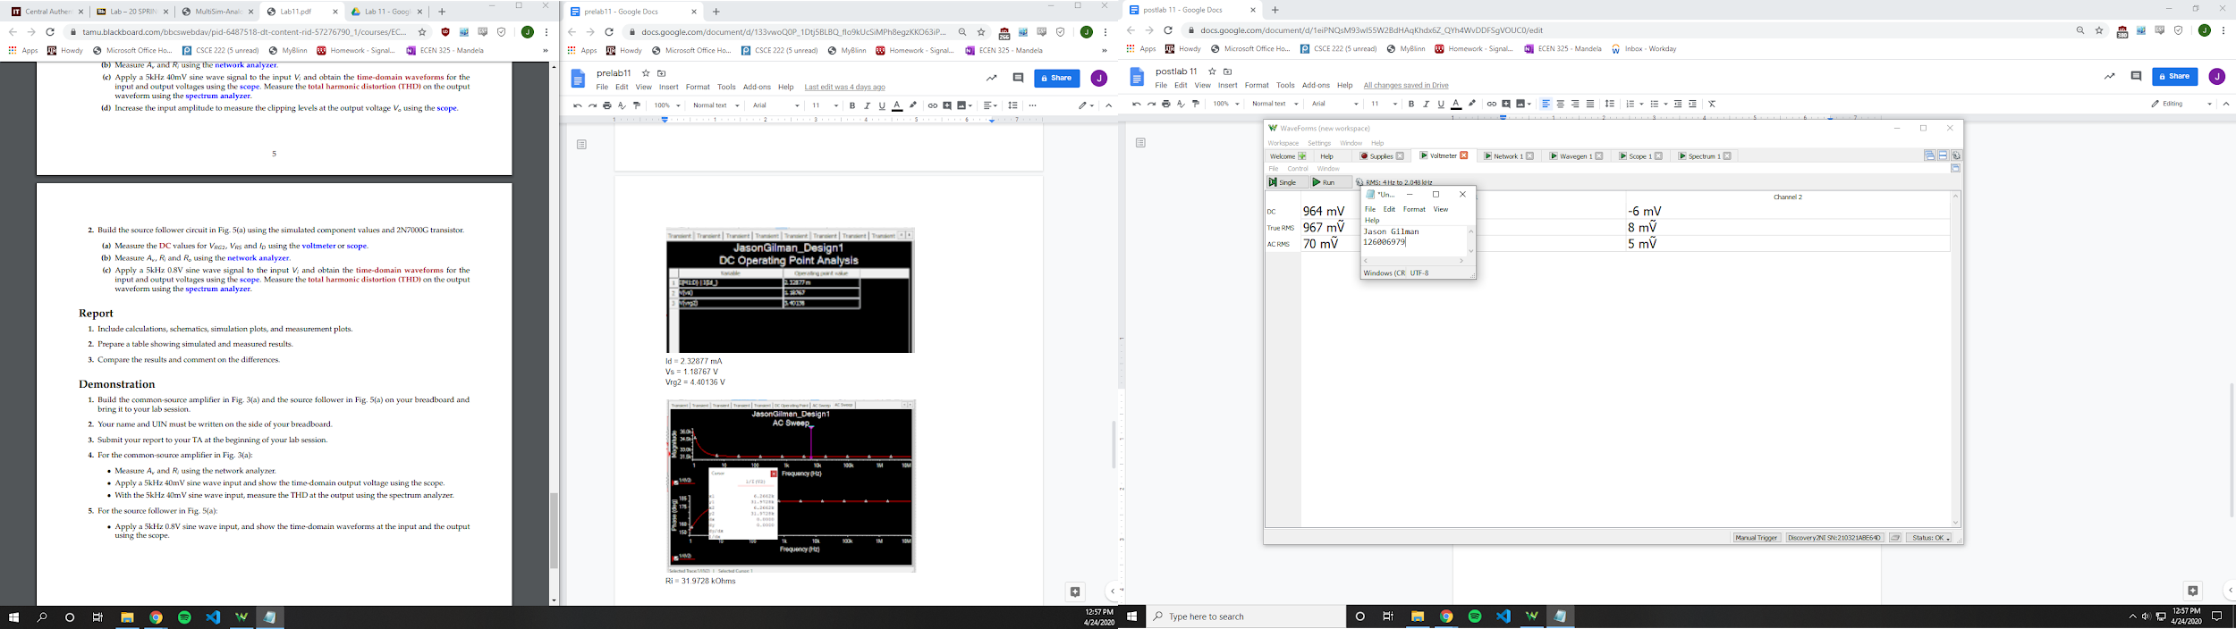

Vrg2 = 3.303 V

Vrs = 964 mV

Id = 37.366 mA

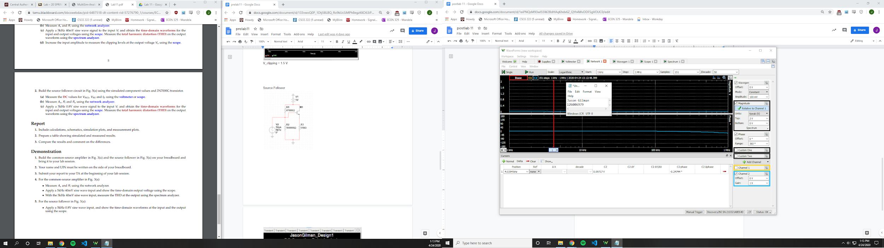

Ri =107.628 Ohms

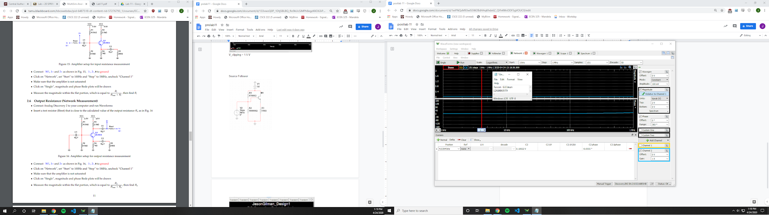

Ro = 111.358 Ohms

Av = 1.03118

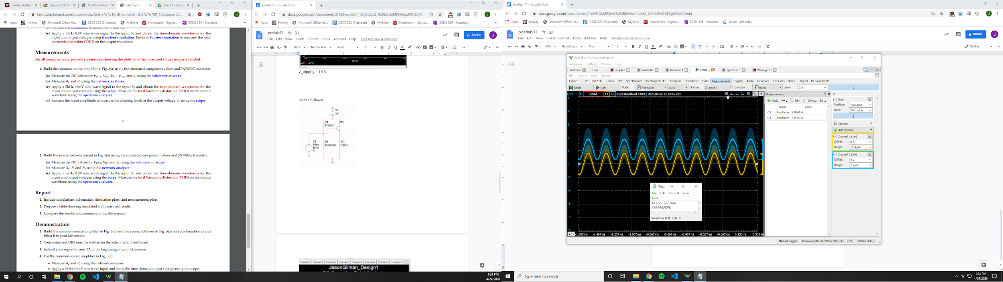

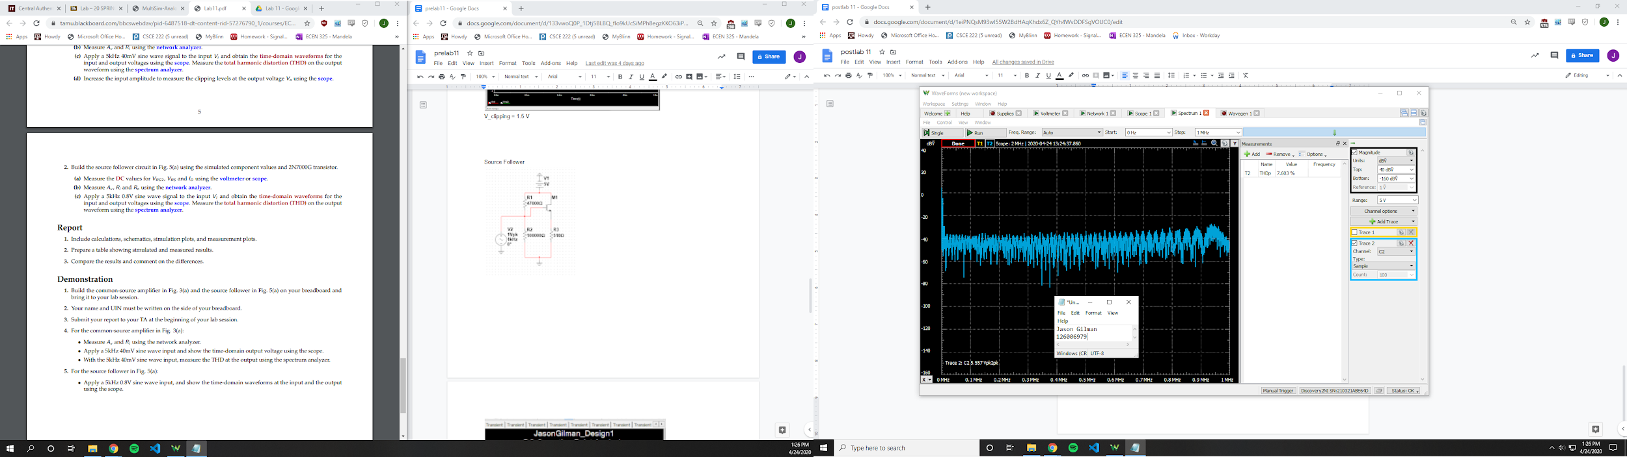

THD = 7.603%

|  |  |  |  |
| --- | --- | --- | --- |
|  | **Calculation** | **Simulation** | **Measurement** |
| **Common Source** |  |  |  |
| Vrg2 | - | 3.40136 V | 3.236 V |
| Vrs | - | .26991 V | .226 V |
| Vrd | - | .2748296 V | .235 V |
| Vo | - | .2748296 V | .235 V |
| Id | - | .52925 mA | .049687 mA |
| Ri | - | 31.9728k Ohms | 28967 Ohms |
| Av | - | 50.47 | 3.35 |
| THD | - | 140.52% | 14.62% |
| V_Clip | - | 1.5 V | 1.2 V |
| **Source Follower** |  |  |  |
| Vrg2 | - | 4.40136 V | 3.303 V |
| Vrs | - | 1.18767 V | .964 V |
| Id | - | 2.32877 mA | 37.366 mA |
| Ri | 31972 Ohms | 31.9728k Ohms | 107.628 Ohms |
| Ro | 485.252 Ohms | 42.0931 Ohms | 111.358 Ohms |
| Av | 0.0485 | 29.6332 | 1.03118 |
| THD | - | 29000% | 7.60% |

**Conclusion**

The results were hard to replicate across the calculations, simulations, and measurements. I think there could have been an issue with the threshold voltage of the Common source circuit. Another issue could have been with the initial design of the circuit. In the ac analysis, the current on the drain could have been calculated incorrectly, which would explain some of the discrepancies in the measurements and simulations.